ERROR HANDELING

FOR ERROR –

Error message "error:0308010C:digital envelope routines::unsupported"

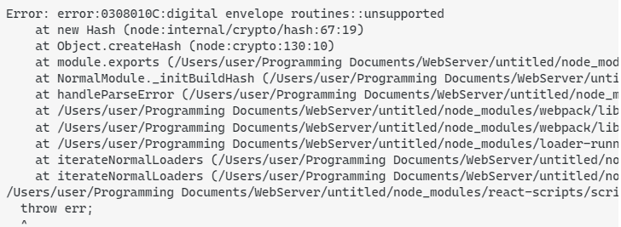

Solution

